Our Development Process

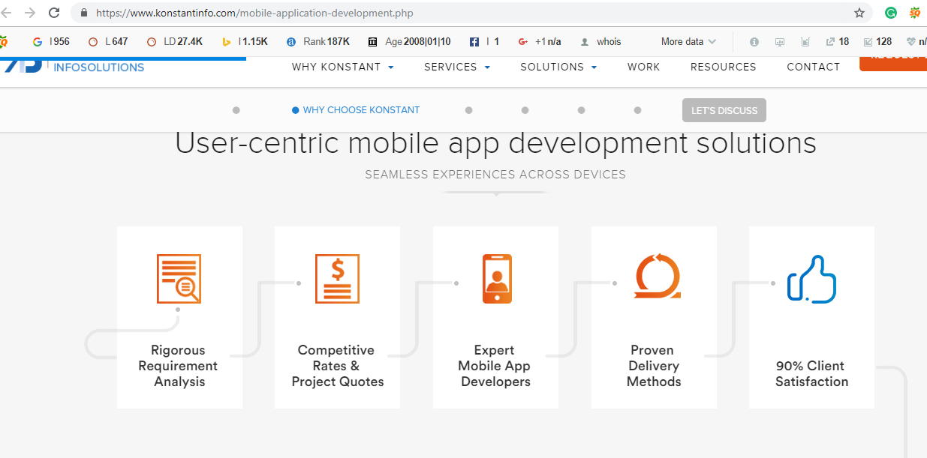

Mobile Application Development process is a unified initiative which involves various process from requirement analysis to support and maintenance.

Before submitting the proposal, we ask appropriate questions to understand exactly the clients need. Once we understand the clients need, we provide a detailed proposal.

Once the proposal is accepted, our team members meet the client to get a greater understanding of the entire project and set guidelines and expectation.

Next, our designers build a blueprint for your application, what it will look like, what fonts will be used and what graphics will be displayed.

Once the design is approved our development team work on the creation of your application and perform various testing. Once all is set with your app, Nunc Systems helps to make sure your app is successfully launched.